Enhancement Specification

Update Custom Costing Selection List Program ZAFGU038

VERSION: 7.0
LAST UPDATED: 05/12/2020

DOCUMENT CONTROL:

REVISION HISTORY:

Version # | Date Modified | Modified By | Brief Description of Change
1.0 | 07/12/2013 | Ram Mohan Thammineni | Initial Draft
2.0 | 10/26/2017 | Keyur Panchal | Updating selection screen for ZAFGU038 program. Needs to include Cross- Plant material status, Bulk Material Indicator, Total stock and Standard price fields to selection
3.0 | 07/11/2018 | Keyur Panchal | Updating Selection screen for ZAFGU038. Checking PP1, PO or production order created for Material or not before selecting for daily costing job.
4.0 | 09/04/2018 | Keyur Panchal | Updating selection screen for ZAFGU038. Adding PO type, account assignment category, item category for selection screen.
5.0 | 10/04/2018 | Keyur Panchal | Updating Selection screen for ZAFGU038. Adding sales org., Distrubution channel, Distribution Chain status.
6.0 | 01/05/2018 | Keyur Panchal | INC04241118 – When material is not extending for Sales org. Program is not generating selection list.
7.0 | 05/12/2020 | Hari Krishna Gedala | Create separate variant to ZAFGU038 program to avoid impact on sales order cost estimation exist.

APPROVALS:

Author | Keyur Panchal | Date Created: | 10/26/2016
Functional Team Lead | Sapan Shenoy | Signature and Date Approved:
Business Process Owner | Seth Wallis | Signature and Date Approved:
Technical Team Lead | Yvonne Tai | Signature and Date Approved:
Project Manager | Sharon Tang | Signature and Date Approved:

TABLE OF CONTENTS:

I. INTRODUCTION 4
A. Purpose of the document 4
B. Request Overview 4
II. OVERVIEW 5
A. Business Driver 5
B. Key business requirements 5
C. High level Process overview 5
D. Alternative Solutions evaluated 5
III. DETAILS 6
A. Detail Processing Logic 6
B. Selection Screen 6
C. Exception Handling Rules 6
D. Special Requirements 6
E. Dependencies 6
F. Constraints 6
G. Scheduling Requirements 7
H. Test Specification 7
1. Functional Test Scenarios 7
2. Test Data & Other Needs 7
3. Test System & Environment 7
I. Audit Requirements/Integrity Controls 7
J. Security/Authorization Requirements 7
IV. TECHNICAL SECTION 8
A. Object Type: 8
B. All Z Objects Information 8
C. Detail Technical Specification 8
D. Open Item / Issues Log / Proposed Solutions (keep all history) 8

INTRODUCTION

Purpose of the document
The purpose of this document is to document any SAP code modification or additional processing logic requirements to further enhance the standard SAP delivered functionality. This document once approved by the appropriate authorities as mentioned in section “Document Control” forms the basis of Technical specification and the development work by the Development team.

Create separate variant to ZAFGU038 program to avoid impact on sales order cost estimation exist.

Version 2.0

Silicon GFP costing selects more than 1Million records for costing purpose and due to that high volume daily costing job taking a long time to execute or sometime background job gets failed. In order to restrict data during selection process ZAFGU038 program requires additional field in selection screen.
- Cross-plant material status (MARA- MSTAE) – to support exclusion for status MI and MW
- Bulk material indicator (MARC- SCHGT) – to support exclusion for ‘bulk’ material
- Total Stock (MBEW-LBKUM) – to support first round CK40N for MAKE with stock on hand
- Standard price (MBEW-STPRS) – to support first round CK40N for BUY without std price

Version 3.0

After Silicon GFP go-live daily costing job select more than 1 million records every day for costing. Due to high volume of data Daily costing job takes almost 14hrs to complete job in one Silicon Plant. Also due to locking issues costing jobs are getting failed for Plant 4070 & 4090.

Request Overview

1. Scenario ID:
2. Scenario Title:
3. Process ID:
4. Process Title:
5. Development Spec ID:
6. Name of Enhancement:
7. Short Description:

8. Type: Function Exit / User Exit Routines SAP Code mod.
Custom program/transaction Other_________________
9. Data latency: Real-time Batch On-demand
10. Frequency: Annually Quarterly Monthly Weekly
Daily Other
11. Requesting Team: ____________________
12. Systems Impacted: R/3 CRM APO EBP BW SEM
Other____________
13. Modules Impacted: FI CO SD MM PP QM BW SEM
Other____________
14. Complexity High Medium Low
15. Spec Created on: 11/10/2014
16. Date required by: 10/30/2017
17. Created by: ___ Ram Mohan Thammineni _____ Phone:
18. Functional Analyst: ___ Keyur Panchal _____ Phone:
19. Technical Analyst: _________________ ___________ Phone:
20. Business Owner: ____Seth Wallis____________ Phone:

OVERVIEW

Business Driver
<Identify the key business driver for this requirement>

Custom Costing Selection List creation program ZAFGU038 does not have input field for taking material from CSV input file.

Version 2.0

Additional fields requires to improve daily costing job performance. Needs to include Cross-plant material status (MARA- MSTAE) ,Bulk material indicator (MARC- SCHGT), Total Stock (MBEW-LBKUM) and Standard price (MBEW-STPRS).

Key business requirements
<Refer here the key business requirements from the requirements list being supported by this development>
Update the custom Costing Selection List creation program to take CSV input file.

Material number only - program will select the material in all plants and create a costing selection list

Material and Plant - program will select just these materials and plants combinations only and create a costing selection list

Version 2.0

Additional fields requires to improve daily costing job performance. Needs to include Cross-plant material status (MARA- MSTAE) ,Bulk material indicator (MARC- SCHGT), Total Stock (MBEW-LBKUM) and Standard price (MBEW-STPRS).

Version 3.0

Additional fields and Check box require to improve daily costing job performance.
- Add MRP SPK ( MARC-SOBSL) to selection screen
- Add OH Group (MBEW-KOSGR) to selection screen

Also, add additional 3 check box button to check below data.
- PP1 Price Check
  - If the check box is check for PP1, then based on Material and plant combination go to MBEW Table look for MBEW-ZPLP1 not equal to blank then include those materials to the selection list. If MBEW-ZPLP1 is blank then exclude those materials from selection list. Sort the Material and plant combination and remove duplicate materials if any.

- PO Exists Check
  - Check if Valid PO exists for material (EKPO-MATNR)
  - Get all PO from EKPO for Materail and Plant combination and get valid PO from EKKO
  - If the check box is check for external PO, then pick the valid external PO materials and include to selection list. Based on the logic list out all PO from EKPO by Materials and Plant combination and get valid EXTERNAL PO from EKKO, If Vendor is in the 80000000-899999 and in table zaf0102 i.e. internal vendor then exclude that PO. Sort the Material and plant combination and remove duplicate materials if any.
  - Also, if PO has deleted status then skip deleted PO. (EKPO.STATU) (EKKO-LOEKZ)

- Production Order Check
  - Check is valid production order exists or created for material and plant combination in AUFK table. If valid production order found then select materials and sort it and delete duplicates if any and include to the selection list.

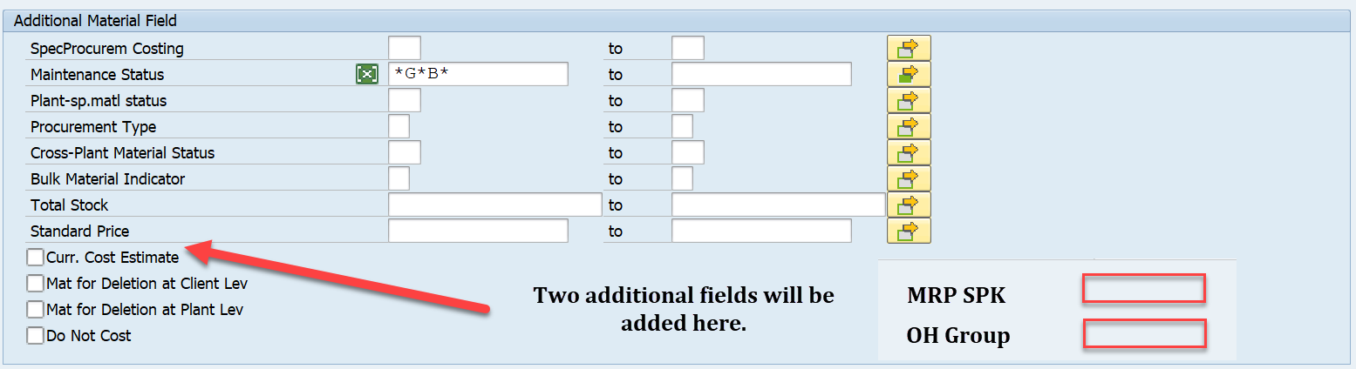

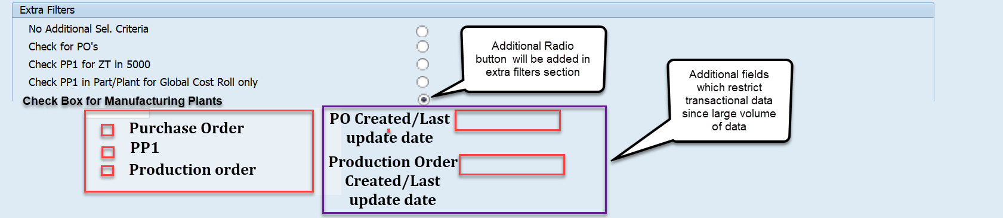

When Purcharse order and/or Production order check. Two field should be poupluated or disaply
- PO Created/Last Update
  - Go to EKPO and get AEDAT (Last changed on) and ZZERDAT (Created date) falls under field days. Select only PO which stratify the condition.
  - Add EKKO AEDAT Since Header data may get change.
  - Also check if PO (Purchase order) is created for SSG plant if yes then go to ZAF0353 table and look for PO created in extended plant. If we find PO for material for any other plant then keep that material in selection.
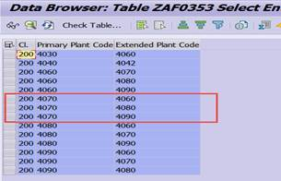

- Production order Create or last update
  - Go to AUFK table and check order is created or updated on given days.
    - Get ERDAT and AEDAT from AUFK table.
    - Get the list of the order for that date.
    - Then goto AFPO and insert order number and material number and Plant.
  - Once have the order data check if order has Released status. ( Create a entry in TVARVC table)
    - Goto AUFK table and get OBJNR and get status number from JEST table.
    - After getting status fro JEST table got to TJ02T and get text for status.
Version 4.0

- Include logic to filter out material with deleted PO when Radio button/ Check box for PO option is selected for AGS and SSG Plants.

  - If EKPO.LOEKZ not equal to blank then do not select PO.
  - When Radio button check for ‘Check PO’s) add selection criteria.


- Include following fields on selection screen
  - PO type to be exclude – Selection screen for both AGS and SSG ( Exclude ZE, ZR, UB,LPA)
    - Add field EKKO. BSART to exclude PO type ( ZE, ZR, UB, LPA)
  - Item category – for PO new field ( exclude L) from EKPO table
    - Add field PSTYP to exclude PO item category.
  - Account assignment category - from EKPO table.
    - Add account assignment category KNTTP to selection screen

- Remove TVAR entry for Production order and make it as selection.
- Add logic check Source plant for AGS, Include logic in AGS “ Check PO’s Radio button”,
  - To Be :After line 1205 look at the source plant has PP1 keep the material.
  - Current logic is only looking for PP1 price in 5000 if it’s greater than Zero. We also need to look for PP1 price in source plant.
  - Get SPK from material master and look for source plant in T460A. If that material has PP1 in source plant keep that material for selection.

Version 5.0

- Include Folloginw Field on Selection screen
  - Sales org. ( MVKE-VKORG)
  - Distrubution channel( MVKE- VTWEG)
  - Distribution Chain status (MVKE-VMSTA)

- Change field name from “ MRP SPK” to “SpecProcurem MRP”

Version 6.0

INC04241118 – When material is not extending for Sales org. Program is not generating selection list.

MVKE table condition is causing an issue so please separate MVKE condition for MARA,MARC and MBEW table selection query.

High level Process overview
<Attach process flow chart and system architecture showing all the concerned systems if required>

Alternative Solutions evaluated
<Identify and document the alternative solutions evaluated and their reason for rejection.>

No. | Alternatives | Evaluation | Reason for rejection  (Cost, Timeline, Change Impact, etc.)
1 |  | Pros:  a.  b.  c.
1 |  | Cons:  a.  b.  c.
2 |  | Pros:  a.  b.  c.
2 |  | Cons:  a.  b.  c.

DETAILS

Detail Processing Logic
<Document in detail the processing logic, identifying the key systems and tables involved. Include pseudo code if appropriate>

Enhance current custom selection list program ZAFGU038 for input file options.

Add following three radio button options in selection parameter:

No input file
Material list (validate above selection criteria) | Provide input field for file selection
Material and plant list ( No validation of above selection criteria) | Provide input field for file selection

No input file – This option needs to be default radio button. Program will behave AS IS. No changes to existing logic

Material list (validate above selection criteria):
  - File format of input file will be :
Material
E1001450
E1001451
  - Material available in the file read and existing selection criteria validation will be followed to arrive with final list of material to be updated in the costing selection list.
  - Example, in the input file material E1001450 is available, which is FERT material. But in the selection criteria, material type entered is HALB, then material E1001450 should be skipped from selecting.

Material and plant list ( No validation of above selection criteria) –
- In this input file will format will be :
Material Plant
E1001450 4030
E1001451 5050
- Material and plant values available in the file, will be read and updated in costing selection list without any further filtering and validation.

- No other impact to existing selection parameter logic

Version 2.0

The current program using MACKW and MBEW for the fields selection as well as program logic. Since ‘Bulk Material Indicator’ is not in existing view needs to update view with MARA, MARC and MBEW table join.

- Cross-plant material status (MARA- MSTAE) – to support exclusion for status MI and MW
- Bulk material indicator (MARC- SCHGT) – to support exclusion for ‘bulk’ material
- Total Stock (MBEW-LBKUM) – to support first round CK40N for MAKE with stock on hand
- Standard price (MBEW-STPRS) – to support first round CK40N for BUY without std price

New Fields on Selection Fields:

Screen Label | Referenced Field | Range of Value | Attributes, Default Values | Validations / Checks | Comments/ Selection Criteria (select options, parameters, radio buttons, checkboxes)
Cross Plant Material Status | MARA- MSTAE | Multiple Selection |  | Yes, | Select Options
Bulk material indicator | MARC- SCHGT | Multiple Selection |  | Yes, | Select Options
Total Stock | MBEW-LBKUM | Multiple Selection |  |  | Select Options
Standard price | MBEW-STPRS | Multiple Selection |  |  | Select Options

Selection Screen
<Describe the selection screen if used. Specify the fields for the selection and what checks need to be done after the user has entered his or her criteria.>

Screen Label | Referenced Field | Range of Value | Attributes, Default Values | Validations / Checks | Comments/ Selection Criteria (select options, parameters, radio buttons, checkboxes)
Input File options
No input file |  |  | Yes |  | Radio button
Material list (validate above selection criteria) |  |  |  |  | Radio button
Material and plant list ( No validation of above selection criteria) |  |  |  |  | Radio button
Input File |  |  |  |  | Field to select file
.

Exception Handling Rules
<Specify instructions to be followed when errors occur, or any processing outside the normal process flow.>

Special Requirements
<Provide any special requirements related to this development effort such as language translations, configurability or personalization allowed, etc.>

Dependencies
<List any dependencies to other technical objects or configuration objects>

Constraints
<Discuss all the constraints or the limitations if any for this technical object>

Scheduling Requirements
<If the specification is for custom program, specify whether jobs should run during off-peak hours, frequency, manual or automatic start. Dependencies, etc>

Version 7.0

Problem: The variant S-ZXCKAU08_INTERNAL_VENDOR has used in TVARVC belongs to sales order costing using for AGS costing and which is causing for incorrect sales order cost estimation by reading the POs due to the selection of the vendors.

Fix: Create new variant in the TVARV which is exclusively to be used for AGS costing and replace with the old variant in the program ZAFGU038.

Test Specification

PROVIDED IN SECTION : IV TECHNICAL SECTION

Functional Test Scenarios
<Document test scenarios to test all of the functional requirements. Include a test scenario for each different business scenario that may occur.>

ID | Test Scenario | Expected Results | Comments
1
2
3

Test Data & Other Needs
<If any, specify test data set-up & refresh needs, volume of data, timeliness of data, etc.>

Test System & Environment
<Identify test system and client.>

Test System: | D08
Client: | 200

Audit Requirements/Integrity Controls
<Specify the controls that are required to ensure that the data has been processed correctly.>

Security/Authorization Requirements
<Provide any special authorization checking or data security provisions required.>

TECHNICAL SECTION

Object Type:
Report ( X ) Interface ( ) Conversion ( ) Enhancement ( ) Workflow ( ) Form ( ) WebDynpro ( ) Other ( ) Specify: _____________

All Z Objects Information
Object Type | ZPROGRAM - ZAFGU038
Object Name | ZAFGU038
Object Description | Replace SAP TCODE CKMATSEL ( Program SAPRCK50)
Development Class | ZAFG
Transaction Code | NA
Message Class | NA
Other Relevant Information | NA

Detail Technical Specification
< Technical details>
* V03 11/20/2014 AravindM Update Custom Costing Selection List *
* Program ZAFGU038 *
*** START OF V03
TYPES: BEGIN OF ty_mat,
matnr(18),
werks(4),
END OF ty_mat.
DATA : it_mat TYPE STANDARD TABLE OF ty_mat INITIAL SIZE 0,
wa_mat LIKE LINE OF it_mat.
*** END OF V03
*** START OF V03
DATA : l_file TYPE string.

*** END OF V03
*** START OF V03
SELECTION-SCREEN BEGIN OF BLOCK b4 WITH FRAME TITLE text-b04.
SELECTION-SCREEN BEGIN OF LINE.
SELECTION-SCREEN COMMENT 1(69) text-t01.
PARAMETERS: p_no_dn TYPE swotgen-download "No Download
RADIOBUTTON GROUP ccc DEFAULT 'X'.
SELECTION-SCREEN END OF LINE.
SELECTION-SCREEN BEGIN OF LINE.
SELECTION-SCREEN COMMENT 1(69) text-t02.
PARAMETERS: p_ml TYPE swotgen-download
RADIOBUTTON GROUP ccc.

SELECTION-SCREEN END OF LINE.
SELECTION-SCREEN BEGIN OF LINE.
SELECTION-SCREEN COMMENT 1(69) text-t03.
PARAMETERS: p_mpl TYPE swotgen-download
RADIOBUTTON GROUP ccc.
SELECTION-SCREEN END OF LINE.
PARAMETERS: p_filpc TYPE rlgrap-filename
DEFAULT 'c:\users\desktop\ZAFGU038.TXT'.
SELECTION-SCREEN END OF BLOCK b4.
*** END OF V03
*** START OF V03
AT SELECTION-SCREEN OUTPUT.

*----------------------------------------------------------------------*
AT SELECTION-SCREEN ON VALUE-REQUEST FOR p_filpc.
*----------------------------------------------------------------------*
CALL FUNCTION 'KD_GET_FILENAME_ON_F4'
EXPORTING
program_name = sy-cprog
dynpro_number = syst-dynnr
field_name = 'P_FILPC'
* STATIC = ' '
* MASK = ' '
CHANGING
file_name = p_filpc
EXCEPTIONS
mask_too_long = 1
OTHERS = 2.
IF sy-subrc <> 0.
MESSAGE ID sy-msgid TYPE sy-msgty NUMBER sy-msgno
WITH sy-msgv1 sy-msgv2 sy-msgv3 sy-msgv4.
ENDIF.
*** END OF V03
*** START OF V03
*** CODE FOR OPTION Material list (validate above selection criteria)
ELSEIF p_ml = c_x.
MOVE p_filpc TO l_file.
CALL FUNCTION 'GUI_UPLOAD'
EXPORTING
filename = l_file
filetype = 'ASC'
has_field_separator = c_x
TABLES
data_tab = it_mat
EXCEPTIONS
file_open_error = 1
file_read_error = 2
no_batch = 3
invalid_type = 5
unknown_error = 7
bad_data_format = 8.
IF it_mat[] IS NOT INITIAL.
*** CODE COPIED FROM ABOVE/OLD CODE WHICH IS ALREADY USED
IF r_rad4 = c_x.
SELECT a~matnr a~werks INTO TABLE it_matlist
FROM mackw AS a
INNER JOIN mbew AS b
ON a~matnr = b~matnr
AND a~werks = b~bwkey
FOR ALL ENTRIES IN it_mat
WHERE a~matnr = it_mat-matnr
AND a~werks IN s_werks
AND a~sobsk IN s_sobsk "Special Procurement Type for Costing
AND a~mtart IN s_mtart
AND a~pstat IN s_pstat
AND a~mmsta IN s_mmsta
AND a~beskz IN s_beskz
AND a~lvora = p_lvora
AND a~lvorc = p_lvorc
AND a~ncost = p_ncost
" AND b~kalkl = p_kalkl
AND b~bklas IN s_bklas .
ELSE.
" End PCR#28858 V02
SELECT a~matnr a~werks INTO TABLE it_matlist
FROM mackw AS a
INNER JOIN mbew AS b
ON a~matnr = b~matnr
AND a~werks = b~bwkey
FOR ALL ENTRIES IN it_mat
WHERE a~matnr = it_mat-matnr
AND a~werks IN s_werks
AND a~sobsk IN s_sobsk "Special Procurement Type for Costing
AND a~mtart IN s_mtart
AND a~pstat IN s_pstat
AND a~mmsta IN s_mmsta
AND a~beskz IN s_beskz
AND a~lvora = p_lvora
AND a~lvorc = p_lvorc
AND a~ncost = p_ncost
AND b~kalkl = p_kalkl
AND b~bklas IN s_bklas .
" Start PCR#28858 V02
ENDIF.
lt_matnr = it_matlist.
SORT lt_matnr BY matnr werks.
DELETE ADJACENT DUPLICATES FROM lt_matnr COMPARING ALL FIELDS.
IF NOT lt_matnr IS INITIAL.
CASE c_x.
WHEN r_rad1.
" Do not Use Extra Filters
WHEN r_rad2.
" Look for any PO that exists for the part, doesn’t matter what they are or
" when they were created – Used for the 5000 variant (note: need to add those REF 5000 parts
" that already have PP1) – Labeled: Check for PO’s. SPK Key is not a factor when looking for approved PO
" Check for material number in table EKPO
REFRESH it_matlist.
SELECT matnr " Material
bwkey " Valuation Area " Plant
bwtar " Valuation Type
zplp1 " Planned price 1
INTO TABLE lt_mbew FROM mbew
FOR ALL ENTRIES IN lt_matnr
WHERE matnr = lt_matnr-matnr
AND bwkey = lt_matnr-werks
AND zplp1 GT '0.00' .
IF sy-subrc = 0.
SORT lt_mbew BY matnr.
LOOP AT lt_matnr INTO ls_matnr.
READ TABLE lt_mbew INTO ls_mbew WITH KEY
matnr = ls_matnr-matnr
BINARY SEARCH.
IF sy-subrc = 0.
APPEND ls_matnr TO it_matlist.
DELETE lt_matnr WHERE matnr = ls_matnr-matnr
AND werks = ls_matnr-werks.
ENDIF.
CLEAR: ls_matnr, ls_mbew.
ENDLOOP.
ENDIF.
IF NOT lt_matnr IS INITIAL.
SELECT matnr
werks
ebeln
ebelp
bukrs
INTO TABLE lt_ekpo FROM ekpo
FOR ALL ENTRIES IN lt_matnr
WHERE matnr = lt_matnr-matnr.
" AND werks = lt_matnr-werks.
IF sy-subrc = 0.
SORT lt_ekpo BY matnr werks.
LOOP AT lt_matnr INTO ls_matnr.
READ TABLE lt_ekpo INTO ls_ekpo WITH KEY
matnr = ls_matnr-matnr
" werks = ls_matnr-werks
BINARY SEARCH.
IF sy-subrc = 0.
APPEND ls_matnr TO it_matlist.
ENDIF.
CLEAR: ls_matnr, ls_ekpo.
ENDLOOP.
ENDIF.
ENDIF.
WHEN r_rad3.

" Check if PP1 exists in plant 5000 (or ZT plant?) – Used for the ZT variants for the regions
" (AMNA, AME, AMSEA) – Labeled: Check PP1 for ZT in 5000
" Check material in plant 5000 in table MBEW for field ZPLP1 not equal to zero
REFRESH it_matlist.
SELECT matnr " Material
bwkey " Valuation Area " Plant
bwtar " Valuation Type
zplp1 " Planned price 1
INTO TABLE lt_mbew FROM mbew
FOR ALL ENTRIES IN lt_matnr
WHERE matnr = lt_matnr-matnr
AND bwkey = '5000'
AND zplp1 GT '0.00' .
IF sy-subrc = 0.
SORT lt_mbew BY matnr.
LOOP AT lt_matnr INTO ls_matnr.
READ TABLE lt_mbew INTO ls_mbew WITH KEY
matnr = ls_matnr-matnr
BINARY SEARCH.
IF sy-subrc = 0.
APPEND ls_matnr TO it_matlist.
ENDIF.
CLEAR: ls_matnr, ls_mbew.
ENDLOOP.
ENDIF.

WHEN r_rad4.

" Check if PP1 exists in the plant selected and ignores the
" current cost estimate’ flag criteria - Used for the Global Cost Roll selection of ZT plant.
" Only want to cost those ZT plants that have a PP1.
" Labeled – Check PP1 in Part/Plant for Global Cost Roll only.
" Check material and plant in table MBEW for field ZPLP1 not equal to zero
REFRESH it_matlist.
SELECT matnr " Material
bwkey " Valuation Area " Plant
bwtar " Valuation Type
zplp1 " Planned price 1
INTO TABLE lt_mbew FROM mbew
FOR ALL ENTRIES IN lt_matnr
WHERE matnr = lt_matnr-matnr
AND bwkey = lt_matnr-werks
AND zplp1 GT '0.00' .
IF sy-subrc = 0.
SORT lt_mbew BY matnr bwkey.
LOOP AT lt_matnr INTO ls_matnr.
READ TABLE lt_mbew INTO ls_mbew WITH KEY
matnr = ls_matnr-matnr
bwkey = ls_matnr-werks
BINARY SEARCH.
IF sy-subrc = 0.
APPEND ls_matnr TO it_matlist.
ENDIF.
CLEAR: ls_matnr, ls_mbew.
ENDLOOP.
ENDIF.

WHEN OTHERS.
ENDCASE.
ENDIF.
ENDIF.
*** CODE FOR OPTION Material and plant list ( No validation of above selection criteria)
ELSEIF p_mpl = c_x.
MOVE p_filpc TO l_file.
CALL FUNCTION 'GUI_UPLOAD'
EXPORTING
filename = l_file
filetype = 'ASC'
has_field_separator = c_x
TABLES
data_tab = it_mat
EXCEPTIONS
file_open_error = 1
file_read_error = 2
no_batch = 3
invalid_type = 5
unknown_error = 7
bad_data_format = 8.

IF sy-ucomm = 'CANC'. "Ensure Transaction exits completly
LEAVE TO TRANSACTION space.
ENDIF.
LOOP AT it_mat INTO wa_mat.
is_matlist-matnr = wa_mat-matnr.
is_matlist-werks = wa_mat-werks.
APPEND is_matlist TO it_matlist.
CLEAR : wa_mat, is_matlist.
ENDLOOP.
ENDIF. "V03
*** END OF V03

“Begin of V06
All MVKE queries are separated from mara mbew queries. Inner join is not used unless there is any sales org field on selection screen filled for filteration. This way if there is no data in MVKE it still fetches all the records unless there is any value in selection screen for any MVKE fields

If VKORG is initial and VTWEG is initial and VMSTA is INITIAL then remove the inner join on MVKE, else keep the query as is.

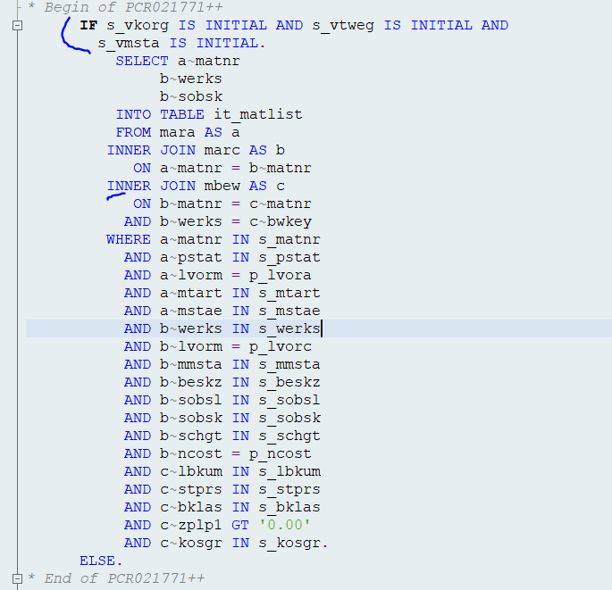
In this case there is no inner join on MVKE
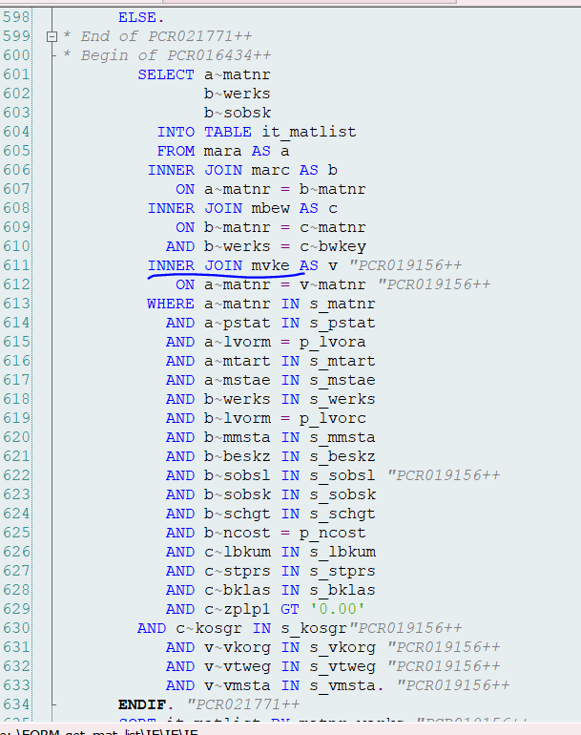
But in else condition inner join on MVKE is there, Same change has been done on all other queries involving these tables
“End of V06

Detail Technical Specification

(System-D08) | 06/09/2020 | Tanmoy Nandy | Replace TVARVC variable in program with new TVARVC variable S-ZAFGU038_INTERNAL_VENDOR

Author | SunilKumar Patti | Date Created: | 06/09/2020
Technical ASM | Kishor Kumar Dash | Signature and Date Approved:
Technical Team Lead | Satyabrata Sahoo | Signature and Date Approved:
Project Manager |  | Signature and Date Approved:

Object Type:
Report ( X ) Interface ( ) Conversion ( ) Enhancement ( ) Workflow ( ) Form ( ) WebDynpro ( ) Other ( ) Specify: __Data Element___________

All Z Objects Information
Object Type | Report
Object Name | ZAFGU038
Object Description | Replace SAP TCODE CKMATSEL ( Program SAPRCK50)
Development Class | ZAFG
Transaction Code
Message Class
Other Relevant Information

PCR029120 - replacement with S-ZAFGU038_INTERNAL_VENDOR
Program - ZAFGU038
Replaced the TVARVC variable
New variable name = S-ZAFGU038_INTERNAL_VENDOR
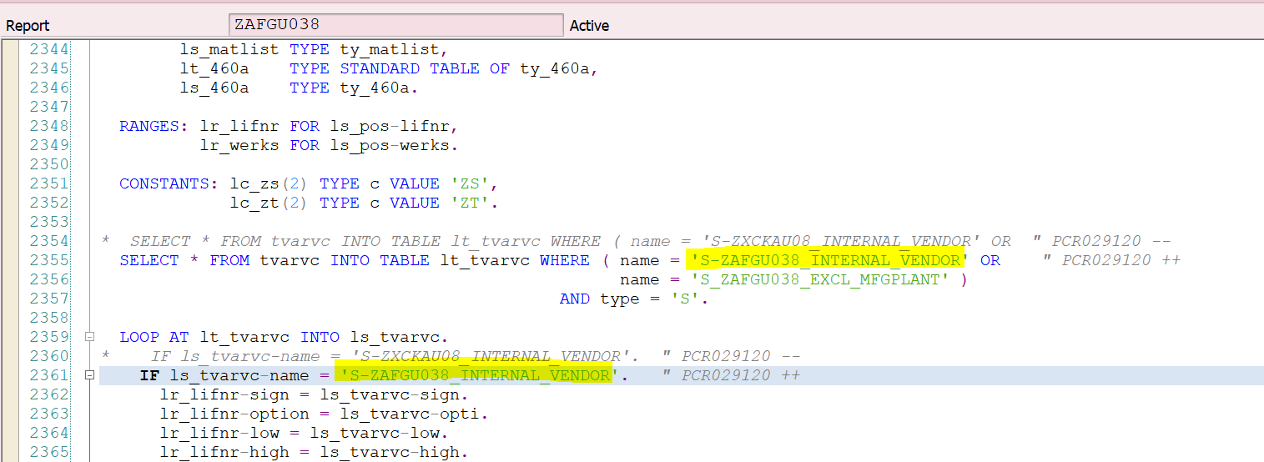
End of PCR029120

Open Item / Issues Log / Proposed Solutions (keep all history)

Assigned To  <Name> | Date Opened | Due Date | Status | Description | Resolution

